MINUTES OF MARSTON MAGNA ANNUAL PARISH COUNCIL MEETING HELD ON MONDAY 16th MARCH 2020

PRESENT: CLLRS Lawrence Hopkins (Chair), Rex Knott (Vice-Chair), Pete Griffiths, Howard Butterfield, Fred Monson, Kathy Lawrence, Andrew Yesson and Lucy Gibbons (Clerk)

Open session
No members of the public were present. Matters brought for discussion:

Coronavirus support. Do we need to coordinate any support? Please keep an eye on your neighbours. If anyone needs help, please contact any member of the PC and we will sort it out. LH will get a notice put in the Parish Magazine giving phone numbers for people to use to Councillors.

1. APOLOGIES FOR ABSENCE – D Cllr/C Cllr Mike Lewis

2. DECLARATIONS OF INTEREST - None

3. THE MINUTES OF THE PARISH COUNCIL MEETING HELD ON 9th January 2020 - Were agreed and signed.

4. MATTERS ARISING – None

5. REPORTS FROM SOMERSET COUNTY COUNCILLOR, DISTRICT COUNCILLORS, PARISH REPRESENTATIVES ON OUTSIDE BODIES AND COUNCILLORS ON THEIR AREAS OF INDIVIDUAL RESPONSIBILITY – As circulated

6. MARSTON MAGNA ACTION GROUP – Met recently and carried out clearance and tidying of Newbury Lane and the Village Hall carpark. Thanks were offered for the great job done by the people who worked so hard.

7. TRAFFIC ALLEVIATION ISSUES- We have received complaints about the speed of vehicles and the inappropriate parking by residents who likely do not have room in front of their houses to park along little Marston Road. This area is becoming very unsafe. This was discussed, but there is no simple solution to the issue.

HB is going to investigate the options for the purchase of a SID. This will need to be chosen carefully to comply with current regulations. We will discuss this at our next meeting.

Update on promised traffic calming measures -
Following the two quite serious accidents in the village at the beginning of the year, an additional request for Chicanes as in Queen Camel was submitted to SCC Infrastructure Programmes Group. At the same time, we asked when the works promised for the financial year ending April 4th would be completed. In our many communications to SCC the importance and urgency of these necessary works were pointed out. We publish their final reply in full.

Dear Howard
Thank you for your e-mail, apologies in the delay in coming back to you.
I can advise that the ordered works are still in planned to take place, but unfortunately all planned works have been suspended to allow focus and prioritisation of safety defect work. As we move into Spring and that calms down, the planned works will again resume. As soon as we have a date, we will let you know.
Your comments regarding the traffic calming have been noted but unfortunately, I do not believe that I can add anything further at this time.

ROAD SAFETY FUND- We agreed that we are happy to enter the 20/20 campaign. We will apply for £250 from the road safety fund to purchase 20 is plenty bin stickers (asking for people to drive at that speed). It will take approximately 6 months to get a decision. HB will make the application and keep the PC informed of progress.
COMMUNITY SPEEDWATCH- HB has registered an interest in the Avon and Somerset Constabulary Community Speedwatch Scheme for Marston. Prior to any scheme starting they will need to carry out an 85%ile Speed Reading at the desired location(s) to ascertain the levels of speeding. Desired location(s) will undergo a two-part risk assessment (part one by the local PCSO part two by the Speed Enforcement Unit) this is to ensure the site is safe and fit for purpose. Volunteers will be needed to help run MM Speedwatch, full training will be given. Please make it known to the PC if you would like to be involved.
8. PLAY PARK –PG has completed the inspection. All equipment is ok, but in need of a spring clean. This will be looked at when appropriate. LH suggested getting a gate made for the end of the bridge in the park. (He will ask the local Mens shed for a price)
9. VILLAGE HALL – Fund raising events are likely to be cancelled for the foreseeable future. Bookings may also be cancelled. There is no further update on the need for a new heating system.
10. FOOTPATHS AND RIGHTS OF WAY -.
Garston Lane sign has been installed but needs to be moved.
LH/RK met with Bob Croft of SW Heritage. He will provide a management plan and memorandum of understanding regarding the maintenance of the Moat Field. They are likely to approach the PC for financial assistance. Some work has already been done cutting overhanging branches.

11. FLOOD ALLEVIATION: Following the meeting with John Nicholson, the Assistant Highway Service Manager for SCC he has confirmed the following;

A359 – Marston Road
- The gullies between points A – D are scheduled to receive a clean of the gully chamber annually and the last annual clean was carried out in November 2019, all reported as functioning.
- The gully at point A is currently surcharging and an interim reactive clean will be instructed to be carried out, which will include all gullies between points A-D. Works instruction to be made when new budget available, from April 2020, and is likely to take up to 3 months to complete due to contractual terms.
- JN has made a bid to secure funding from the SRA to have a catchment area survey carried out, for surface water flooding (inc watercourses), to include Rimpton and Marston Magna. The latest update they have received is that funding has been agreed in principal and once they are informed of the final agreement, they should receive funding and would expect a survey to have been completed by Sept 2020. This survey will provide information to identify solutions which can then be implemented as required, once suitable funding has been established. This may also require involvement from Riparian owners for ordinary watercourses with their commensurate responsibilities.
- The Non-Return Valve Flaps require attention, at points B – D, JN will discuss their replacement with the SCC FWMT.
- The SCC Bridges section has been notified of the silt directly beneath the structures, points B – D, which is the section JN understands that they would be responsible for, but it is unlikely that they will carry out any works until the mid-sections have been de-silted. They may be contacted directly via Bridges@somerset.gov.uk. The footbridge at Point B is with Rights of Way responsibility but JN is unsure of their responsibility with regards to the watercourse directly beneath that therefore he will request clarification from them.
- JN is currently discussing the silt build up, between points B – D for the mid-sections, with the SCC Flood and Water Management Team (FWMT) to understand the riparian responsibilities for that section of ordinary watercourse. I will request a land registry search and begin discussions with the relevant owners. JN hopes that the land registry search and discussions could be resolved quickly so that necessary de-silting can be carried out regardless of the SRA survey, but at present he is unable to provide any funding possibilities or timescales for that.
- The localised flooding at Point E, at times, is likely to be resolved following the survey and possible options from that.
Little Marston Road
- Jetting along Little Marston Road has been carried out previously with some observations of possible compromised sections of highway drainage by infiltrated root masses. Should there be any maintenance/replacement of sections of the highway drainage due JN will instruct this to be carried out. Budget for this type of work will become available from April 2020 and would hope to achieve any necessary work completion by Nov 2020.
Rimpton Road
- A jetting order was previously raised to carry out some jetting to the highway drainage system around the location of Garston Farm entrance to verify the system condition at that location. Due to other resource burdens it is unlikely that the jetting will be carried out in this financial year therefore JN will have to issue a new order for that work and would expect that to be completed within 3 months of April 2020 which will then inform the necessary works (if any), likely completion 3 months from investigating that jetting report.

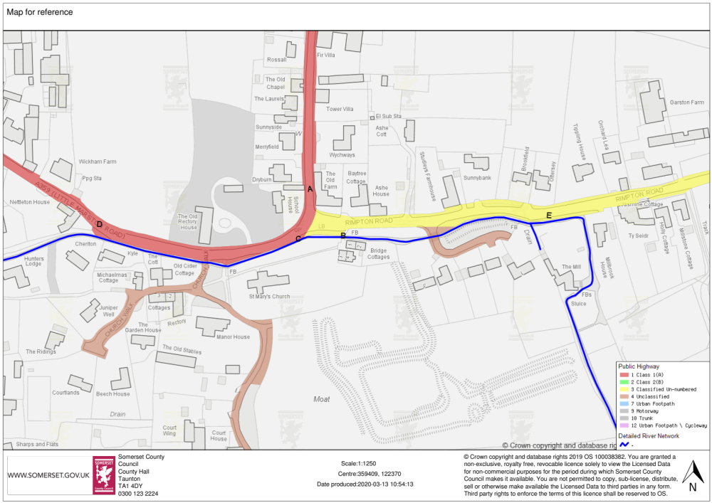

LH has provided contact details for R Vaux of the Parrett Drainage Board, so that they can work together on areas relating to the stream.
12. THE MARSTON INN - AN ASSET OF COMMUNITY VALUE – Community interest groups have the right to identify a building or other land that they believe to be of importance to their community's social well-being and nominate it to be listed on the Council’s Register of Assets of Community Value. If the nominated asset meets the definition of an asset of community value, we must list it, notify the owner and the Land Registry. The owner will have a right to a review by the council and an appeal to an independent tribunal. Nothing further will happen until the owner decides to dispose of the asset, either through freehold sale or the grant of a lease for at least 25 years. At this point, they must notify us of their intention to sell. The owner will only be able to dispose of the asset after a specified time period, known as a 'moratorium', has expired. This allows for the group to raise funds to buy the asset. It was agreed that HB will register our interest in The Marston Inn.
There appears to be a vehicle recovery/sales business being run from the Car park of the Marston Inn. LG to contact the planning department to see if this is lawful.

13. CHAIRMANS ANNOUNCEMENTS – Plans for the Annual Village Meeting may have to be put on hold? We will decide nearer the time.

14. CORRESPONDENCE – None received

15. PLANNING;
(a) APPLICATIONS CONSIDERED (UNDER STANDING ORDER 3(b)(xvi)) BEFORE THIS MEETING:
20/00283/HOU
The erection of a detached double garage – Sandwell, Marston Magna Road.
Marston Magna Parish Council has no objection to this application although it is very close to the neighbour’s boundary. We do, however, strongly object to the red cedar finish which once more is totally out of keeping with the neighbouring two properties. The finish should be of similar material to match the house.
Additionally, when planning permission was originally given for the 3 houses in this lane, one of the conditions was that the wall between them was maintained as this was an original wall and deemed to be an item of interest. The garage appears to be tight up against the boundary and will therefore not allow maintenance of the wall which it now needs, on both sides. We would also point out that the holly hedge fronting Dunelm along the lane is subject to a preservation order. Whilst the extensions to Sandwell will not affect the hedge, putting a fence along the front of Sandwell will contrast sharply with it and spoil the amenity view.

19/03495/FUL. Re-clad part of dwelling, close in existing porch, convert and extend existing garage into sunroom/utility room, alterations and new external door and erection of boundary fencing, gate piers and new gate (part retrospective) – Sandwell, Marston Road.
Marston Magna Parish Council have no objection to the extension of the porch and garage.
We do however object to the use of Western Red Cedar cladding. We feel strongly that this should be done in a suitable material of matching stone. The use of cladding here and on the existing structure is totally out of keeping with surrounding properties.
It was a condition, of a similar application, for a neighbouring property (No 13/00971/FUL-condition 02) that the materials used in the external construction should be of stone. This was in the interest of visual amenity to accord with ST6 of the South Somerset local Plan. We believe that a similar condition should be applied to this application.
We also object to the closing in of the front garden by gates and fencing. This spoils the open aspect of the area which has been in existence since construction in 1972 and is out of character with the conservation area, surrounding properties and the setting of the protected Grey Cedar trees.
An Amendment to this application has also been submitted, reducing the cladding on front elevation.
The Parish Council do not feel that this is appropriate, and our original comments still apply.

9/03520/HOU. Erection of single storey rear extension and first floor side extension to dwelling house – Baggcroft, Rimpton Road.
Marston Magna Parish Council have no objections to the erection of the two extensions to this property.
We do however object to the use of cladding on the first-floor extension. We feel strongly that the finish should be in natural stone to match the existing finish. There are no properties in Rimpton Road with any such timber cladding finish and we believe that this is out of character for this area of our village.
When the two neighbouring houses were built in 2009, Holly Cottage and Millstone House, it was a condition of the planning approval that local stone was used on walls facing Rimpton Road. This was seen as being necessary because this section of Rimpton Road is within the conservation area.
It is proposed that the rear extension will have a render finish. Because it is clearly behind the house, we have no objections to this.
Amendments were then submitted, include the replacement of timber cladding to the first-floor extension with natural stone, removal of one proposed porch and simplification of an additional porch, and the addition of two dormer windows to front and one to rear of dwellinghouse and one conversion rooflight to the rear.
The Parish Council are very pleased with this amendment to use natural stone, rather than timber cladding.
We have no objections to the additional amendments.

(b) APPLICATIONS FOR CONSIDERATION: None
(c) APPLICATIONS RECEIVED AFTER THE PUBLICATION OF THE AGENDA: 20/00389/LBC The Old Rectory House, Marston Magna Road. Listing Building consent for internal alterations to facilitate a ground floor bathroom – The PC have no objections to this application.

(d) PLANNING DECISIONS RECEIVED: None

16. FINANCE;
a) CHEQUES REQUIRED FOR SIGNING: - L Gibbons- Clerk. Salary Jan-Mar £547.20, Mileage £9.00, New printer and Ink £108.48. All Payments approved.

b) REPORTING OF CHEQUE SIGNED PRIOR TO THE MEETING: Audio Visual Direct - Hearing Loop for Village Hall £1189.20
c) BANK RECONCILLIATION – Was agreed and signed.

17. QUESTIONS AND ITEMS ARISING AFTER THE PREPARATION OF THIS AGENDA, SUCH MATTERS ARE FOR NOTING OR
DEFERRAL TO A FUTURE MEETING. – None.

18. ITEMS FOR NEXT MEETING: SID

DATES OF THE NEXT MEETINGS: (Annual Village Meeting – We will decide nearer the time if this is to be held) and Annual meeting of the Parish Council - 20TH MAY 2020.

